International Conference
on
Sustainable Computing in Science, Technology & Management
(SUSCOM-2019)
February 26 - 28, 2019 | Amity University Rajasthan, Jaipur, India

Submission Guidelines for Authors

- Open the easy chair link: https://easychair.org/conferences/?conf=suscom2019
- Type your easy chair user name and password. If you don’t have easy chair account then “Create an account” and follow the steps.

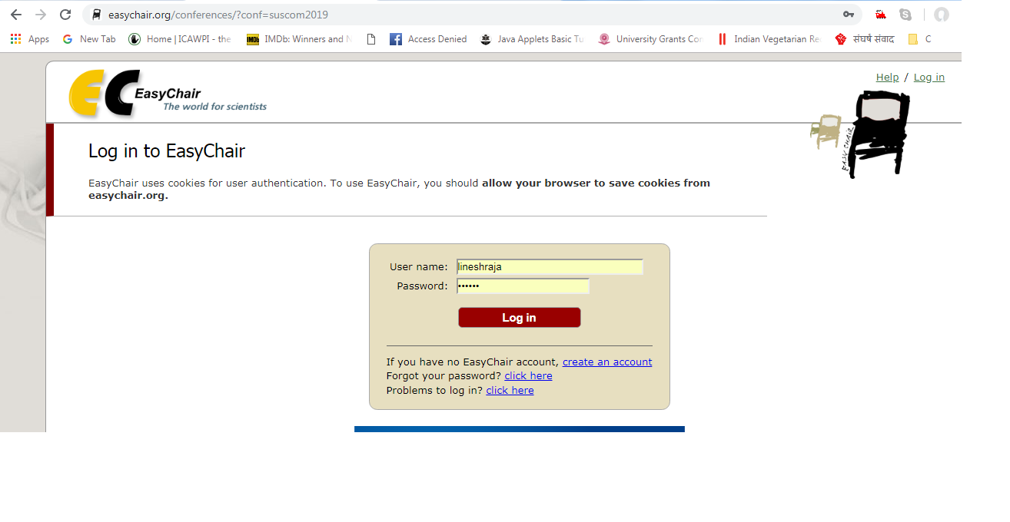
- To submit the paper click on “enter as an author”.
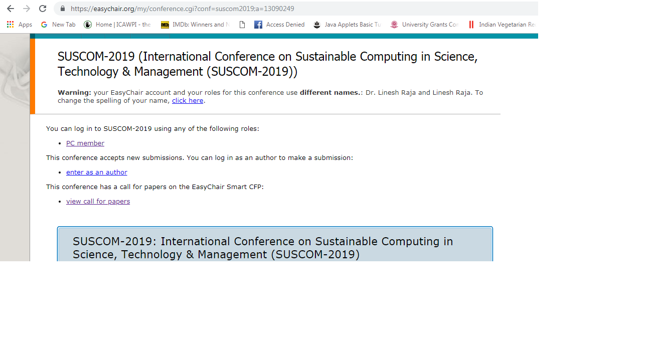
- Start with “New Submission for SUSCOM-2019”. Enter the following information’s:
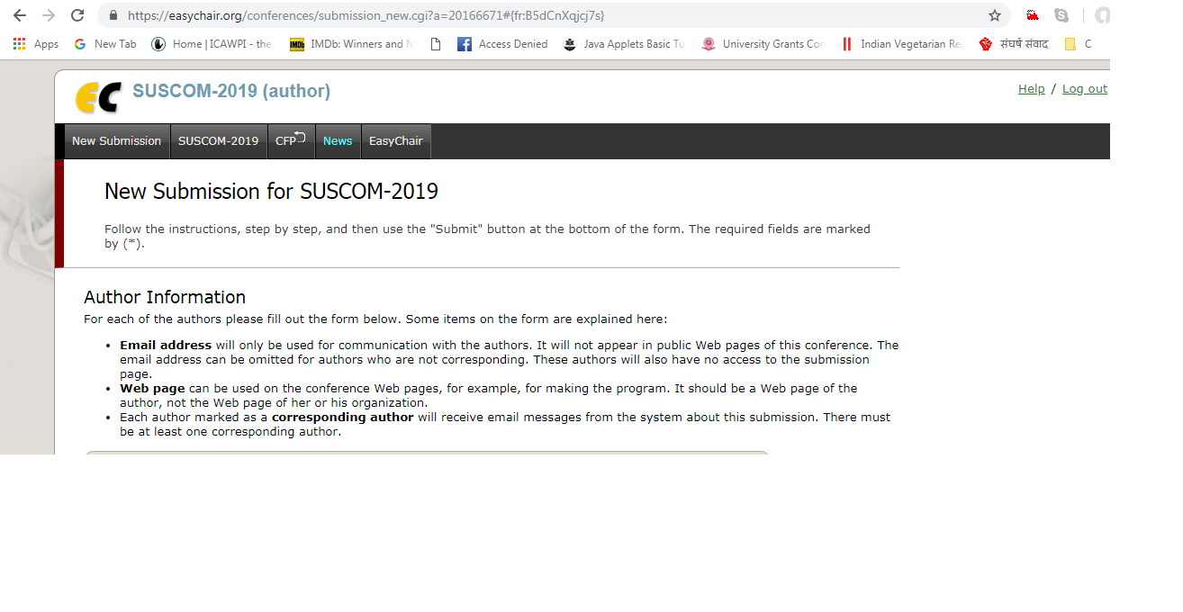

  - Author Information
  - Title and Abstract
  - Keywords
  - Topics

- Important instructions regarding Point 4.d:
- Please select topics relevant to your submission from the list.
- If paper belongs to any track from 1-9, kindly select the track sub title.
- If paper belongs to any Special Session, kindly select the special session.
- Special Session chair and co chair are requested to inform the potential authors to select their Special Session Track Only. It helps us to filter paper for your special session.

